**REFERENCES**

1. Kunxiawang , Ning An, Bing Nan Li , Yanyong Zhang, ”Speech EmotionRecognition Using Fourier Parameters”,Intelligent Computing and Intelligent Systems (ICIS), Vol. 6, pp. 69-75,Jan 2015.
2. Md. Touseef Sumer, “Salient Feature Extraction For Emotion Detection Using Modified KullbackLeibler Divergence”, Internationl Journal of Research in Engineering and Applied Science (IJREAS),Vol. 2, pp. 60-69, Jan 2014.
3. VidhyasaharanSethu, EliathambyAmbikairajah and Julien Epps, “On The Use Of Speech Parameter Contours For Emotion Recognition”, EURASIP Journal on Audio, Speech, and Music Processing, Vol. 2,pp. 36-46, Oct 2013.
4. BiswajitNayak, MitaliMadhusmita and Debendra Ku Sahu, “Speech Emotion Recognition using Different Centred GMM”, International Journal of Advanced Research in Computer Science and Software Engineering,Vol. 3, pp. 55-64. Sep 2013.
5. Akshay S. Utane and Dr. S.L .Nalbalwar, “ Emotion Recognition Through Speech Using Gaussian Mixture Model And Hidden Markov Model” International Journal of Advanced Research in Computer Science and Software Engineering,Vol.4, pp.34-45, April 2013.
6. Stavros Ntalampiras and Nikos Fakotakis, “Modeling the Temporal Evolution of Acoustic Parameters for Speech Emotion Recognition”, IEEE Transactions On Affective Computing, Vol.3, pp. 167-175, January-March 2012.
7. Chung-Hsien Wu and Wei-Bin Liang, “Emotion Recognition of Affective Speech Based on Multiple Classifiers Using Acoustic-Prosodic Information and Semantic Labels”, IEEE Transactions On Affective Computing, Vol. 2, pp.10-19, January-March 2011.
8. Yuan Yujin, Zhao Peihua and Zhou Qun, “Research of speaker recognition based on combination of LPCC and MFCC”, Intelligent Computing and Intelligent Systems (ICIS), Vol. 12, pp. 269-275, Oct 2010.
9. Carlos Busso, Sungbok Lee and Shrikanth Narayanan,”Analysis of Emotionally Salient Aspects of Fundamental Frequency for Emotion Detection” ,IEEE Transactions On Audio, Speech, And Language Processing, Vol. 17, pp. 582-596, May 2009.

[10] Daniel Neiberg, KjellElenius and KornelLaskowski,” Emotion Recognition in Spontaneous Speech Using gmms”, Vol. 2,pp.56-65,2008 .

[11] Mohammed E. Hoque, Mohammed Yeasin and Max M. Louwerse, “Robust Recognition of Emotion from Speech”,Intelligent Virtual Agents, Vol.12, pp. 42-53, 2006.

[12] Chul Min Lee and Shrikanth S. Narayanan, “Toward Detecting Emotions in Spoken Dialogs”, IEEE Transactions On Speech And Audio Processing, Vol. 13, pp. 293-303, March 2005.

**APPENDIX 1**

**CODING**

functionvarargout = gui_final(varargin)

gui_Singleton = 1;

gui_State = struct('gui_Name', mfilename, ...

'gui_Singleton', gui_Singleton, ...

'gui_OpeningFcn', @gui_final_OpeningFcn, ...

'gui_OutputFcn', @gui_final_OutputFcn, ...

'gui_LayoutFcn', [] , ...

'gui_Callback', []);

ifnargin&&ischar(varargin{1})

gui_State.gui_Callback = str2func(varargin{1});

end

ifnargout

[varargout{1:nargout}] = gui_mainfcn(gui_State, varargin{:});

else

gui_mainfcn(gui_State, varargin{:});

end

functiongui_final_OpeningFcn(hObject, eventdata, handles, varargin)

handles.output = hObject;

a=ones([200 450]);

axes(handles.axes1);imshow(a);

axes(handles.axes2);imshow(a);

guidata(hObject, handles);

functionvarargout = gui_final_OutputFcn(hObject, eventdata, handles)

varargout{1} = handles.output;

functioninp_voice_Callback(hObject, eventdata, handles)

cdDatasamples

file=uigetfile('*.wav');

inp=wavread(file);

[ speech, fs, nbits ] = wavread(file);

cd ..

wavplay(inp,44200);

axes(handles.axes1);

plot(speech);title('Input Voice Signal');

handles.speech=speech;

handles.fs=fs;

handles.nbits=nbits;

handles.file=file;

guidata(hObject, handles);

functionpre_process_Callback(hObject, eventdata, handles)

speech=handles.speech;

filt_sig=medfilt2(speech,[3 3]);

wavplay(filt_sig,44200);

axes(handles.axes2);

plot(filt_sig);title('Filtered Signal');

handles.filt_sig=filt_sig;

guidata(hObject, handles);

functionfft_Callback(hObject, eventdata, handles)

filt_sig=handles.filt_sig;

[rows cols] = size(filt_sig);

fft_sig =fft(filt_sig,[rows cols]);

figure;

plot(fft_sig);title('FFT Signal');

handles.fft_sig=fft_sig;

guidata(hObject, handles);

functionfeatures_Callback(hObject, eventdata, handles)

inp=handles.speech;

fs=handles.fs;

nbits=handles.nbits;

fft_sig=handles.fft_sig;

f1=max(max(fft_sig));

f1 = abs(f1);

f2=min(min(fft_sig));

f2 = abs(f2);

f3=mean(mean(fft_sig));

f3 = abs(f3);

f5=mean(mean(abs(medfilt1(fft_sig))));

f5 = abs(f5);

f6=std2(fft_sig);

f6 = abs(f6);

p= hist(inp);

f7= -sum(sum(p.*log2(p)));

f7 = abs(f7);

f8=entropy(inp,256);

f8 = abs(f8);

[f9, t] = FeatureTimeZeroCrossingRate(inp, 42100, 256,256);

f9=mean(f9);

f9 = abs(f9);

% f10=sum(sum(fft_sig));

% f10 = abs(f10);

**APPENDIX- 2**

**SAMPLE SCREENSHOT**

**System to detect emotion**

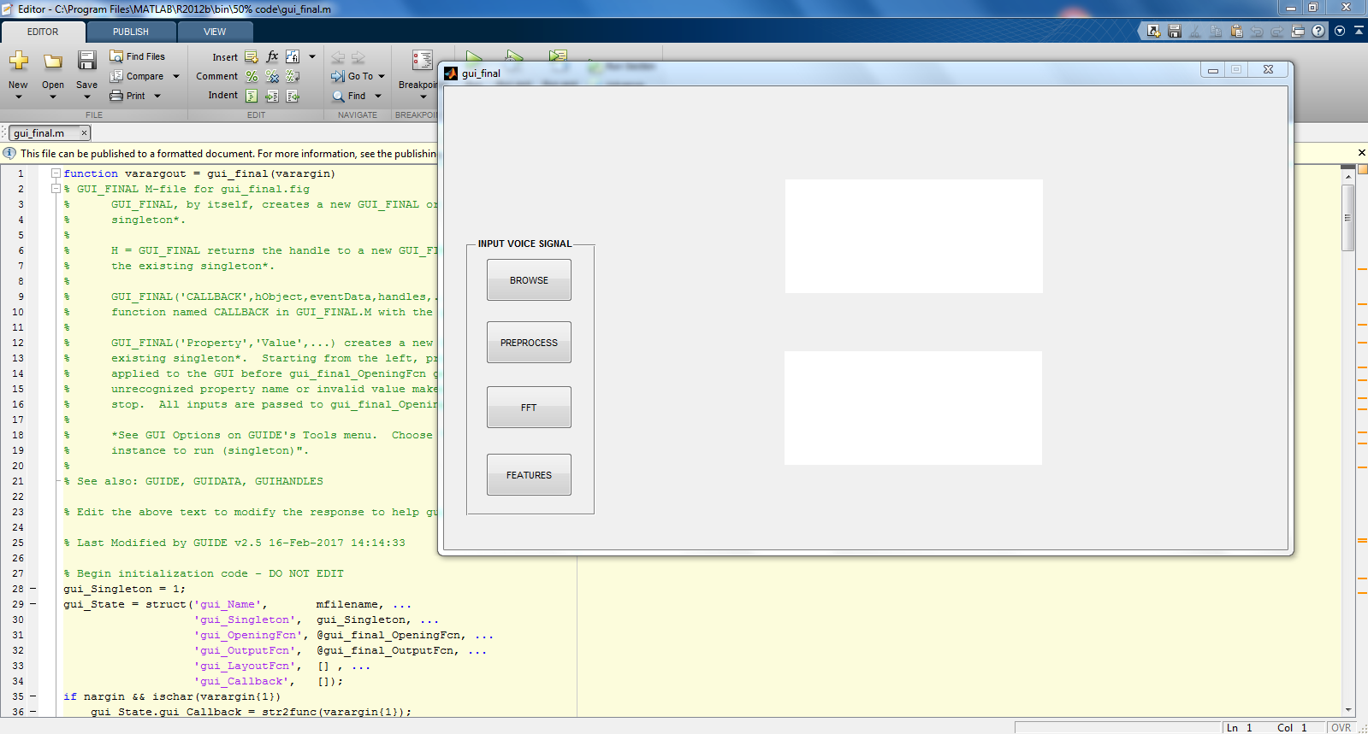

**A2.1**

**Coding page in MATLAB**

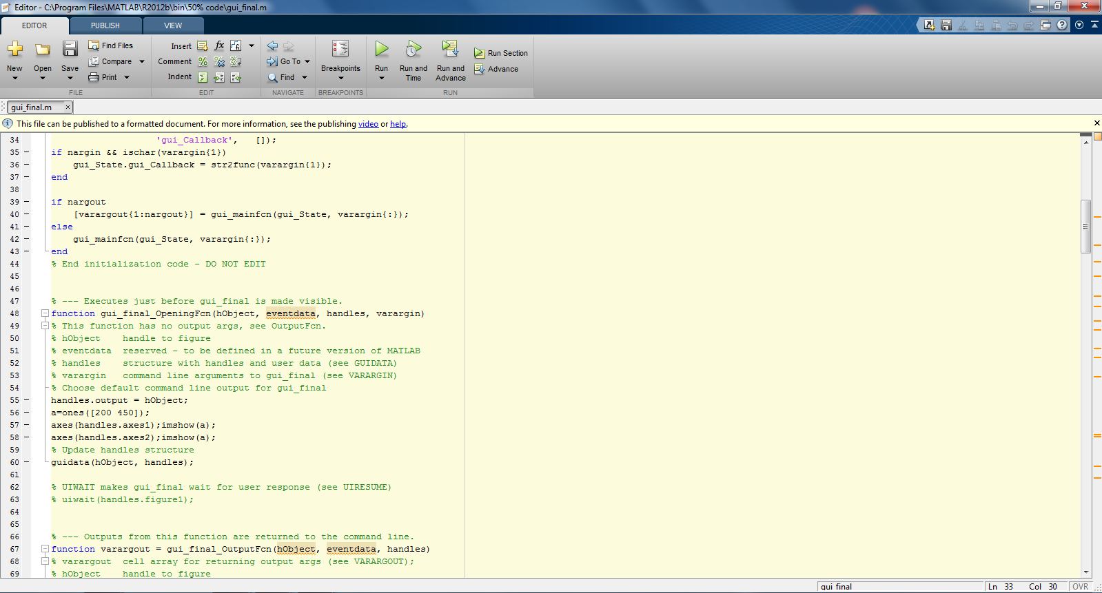

**A2.2**

**Graphical User Interface for designing in MATLAB**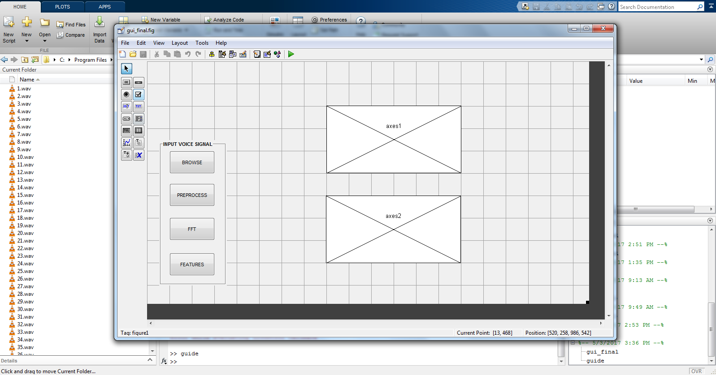

**A2.3**

**Command Window of MATLAB**

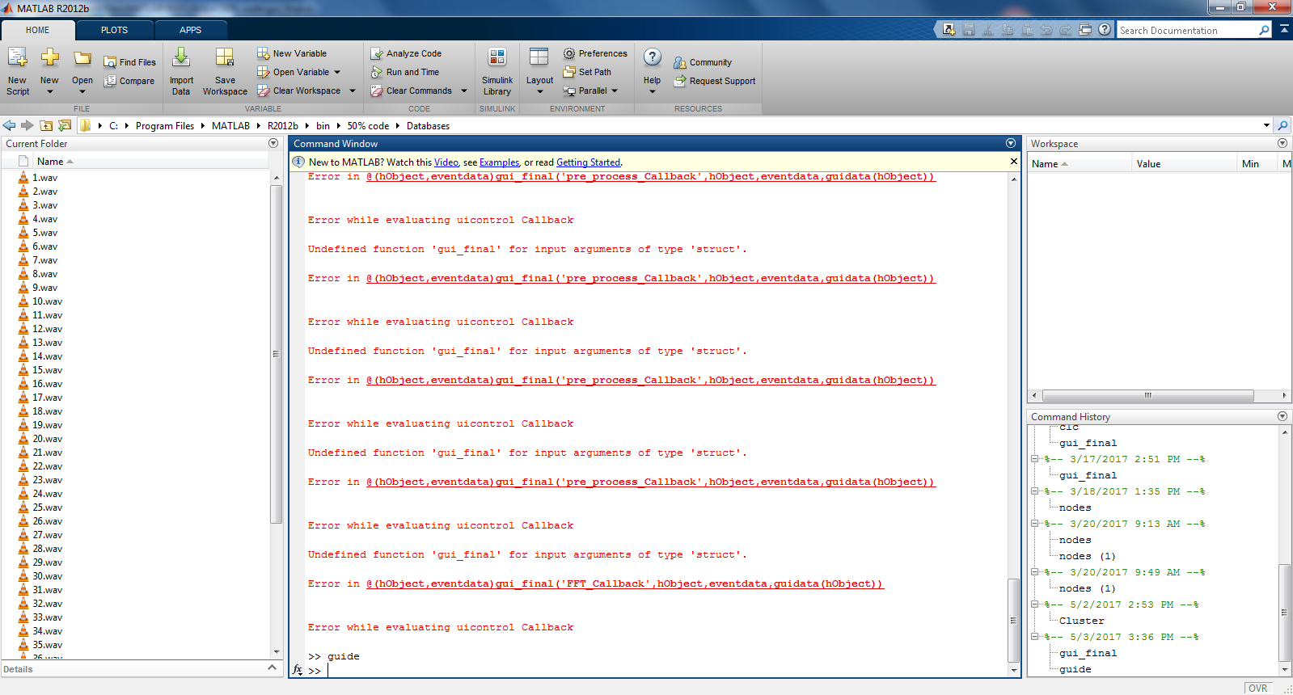

**A2.4**

**Fast Fourier Transform of speech signal**

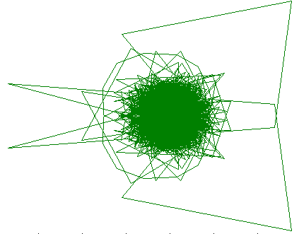

**A2.5**

**TECHNICAL BIOGRAPHY**

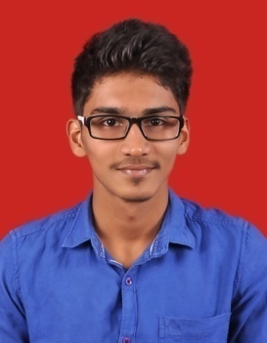

**Mr. ARUN GOPAL.G (130071601012)**  born on 09th January 1996, in Chennai, Tamil Nadu. Completed my schooling in SitaDevi Garodia Hindu Vidyalaya Matriculation Higher Secondary School, secured 92.33% in the Higher Secondary Examination and pursuing B.Tech Computer Science and Engineering at B.S. Abdur Rahman Crescent University. My area of interests includes playing and watching Cricket. My e-mail ID: aarunkarthii@gmail.com and contact number: 8056012274.

**TECHNICAL BIOGRAPHY**



**Mr. CHRISTY XAVIER RAJ.K (130071601021)**  born on 31th October 1995, in Pudukkottai, Tamil Nadu. Completed my schooling in Vairams Matriculation Higher Secondary School, secured 87% in the Higher Secondary Examination and pursuing B.Tech Computer Science and Engineering at B.S. Abdur Rahman Crescent University. My area of interests includes playing and watching Football. My e-mail ID: sterlingkriz@gmail.com and contact number: 9500580692.